Do zoos help or harm animals?

What do you think? Do you agree or disagree? Perhaps you can think of ideas for both sides of this topic.

Write to convince a reader of your opinion:

- Start with an introduction.
- Write your opinion on this topic.
- Give reasons for your opinion.
- Explain your reasons for your opinion in your body paragraphs.
- Finish with a conclusion. Sum up your writing to convince a
reader of your opinion.

Remember to:
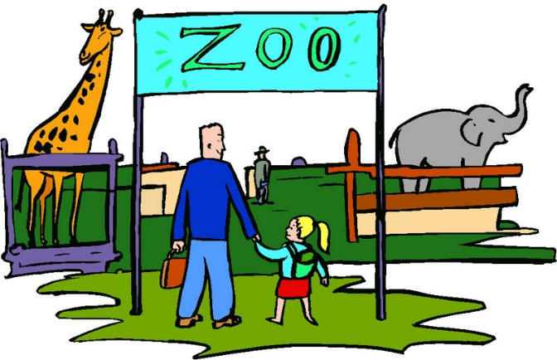
- Plan your argument.
- Choose your words carefully to convince a reader.
- Write in full sentences.
- Pay attention to spelling and punctuation.
- Use paragraphs to organise your ideas.
- Check and edit your writing.

